OpenG Dictionary Class

User Guide

1 Introduction 2
1.1 Scope 2
1.2 Basic properties of the dictionary 2
1.3 List of OpenG Dictionary Functions 2
2 Dictionary Functions 2
2.1 Create 2
2.2 Destroy 3
2.3 Copy 3
2.4 Get Value 3
2.5 Has Key 4
2.6 Get Values 4
2.7 Get Keys 4
2.8 Pop Item 5
2.9 Get Items 5
2.10 Delete Element 5
2.11 Clear 6
2.12 Update 6
3 References 8

Introduction

The OpenG Dictionary Class is based on Python Dictionary [Ref. 1] which provides basic functions to manage key – value pair type of data where each value has a unique key. The value can contain references to any type of object somewhat like a hash table.

Scope
This document describes the OpenG Dictionary Class. It describes each function and lists the types of inputs and outputs associated with them.

Basic properties of the dictionary
- A dictionary is a non-ordered set of key-value pairs
- Keys and values may be of any type.
- A key, is a reference to one and only one value within the dictionary – each key of a dictionary is unique.
- A Value can be read/updated/deleted from the dictionary by referring to its unique key
- Writing a value to an existing key will overwrite the older value associated with that key
- If the key does not exist, the new key-value pair will be added to the dictionary

List of OpenG Dictionary Functions
Following is the list of functions available in OpenG Dictionary Class.
- Create a dictionary
- Destroy a dictionary
- Copy an existing dictionary
- Get value(s) from the dictionary
- Check whether a key within the dictionary
- Get all keys from the dictionary
- Get all key - value pair(s) from the dictionary
- Delete an element from the dictionary
- Empty an existing dictionary
- Write/Update value(s) to the dictionary

All of the above functions are discussed in detail in next section.

Dictionary Functions

Create
Function Name: Dictionary Create.vi
Creates a new instance of empty dictionary data and returns a dictionary reference associated with the newly created dictionary.

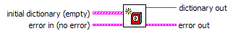

Inputs
initial dictionary (empty): It is the data to be written in the newly created dictionary. By default, it is creates an empty dictionary.

Outputs
dictionary out: It is the reference to the newly created dictionary.

Destroy
Function Name: Dictionary Destroy.vi
Destroys the dictionary.
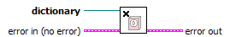

Inputs
dictionary: Reference to the source dictionary

Outputs
None

Copy
Function Name: Dictionary Copy.vi
Creates and returns a copy of the dictionary.
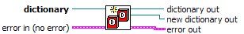

Inputs
dictionary: RefNum of the source dictionary

Outputs
dictionary out: It is a duplicate reference of the source dictionary
new dictionary out: It is the object refnum linked to the new dictionary

Get Value
Function Name: Dictionary Get Value.vi
Returns the value associated with key, if it exists. If the dictionary has the specified key, then found? will be TRUE.
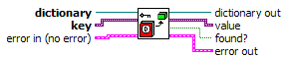

Inputs
dictionary: Reference of the source dictionary
key: The function looks for this key in the dictionary

Outputs
dictionary out: It is a duplicate refnum of the source dictionary
value: This value is an output of the function associated with supplied key in the dictionary
found?: This boolean returns TRUE if key found, else returns FALSE

Has Key
Function Name: Dictionary Has Key.vi
Determines if the supplied key is present in the dictionary.

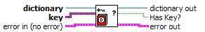

Inputs
dictionary: Reference of the source dictionary
key: This is the key to be searched in the dictionary

Outputs
dictionary out: It is a reference to the source dictionary
Has Key?: This boolean returns TRUE if key found, else returns FALSE

Get Values
Function Name: Dictionary Get Values.vi
Returns all of the values within the dictionary.

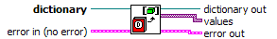

Inputs
dictionary: Reference of the source dictionary

Outputs
dictionary out: It is a reference to the source dictionary
values: This is an array of all the values read from the dictionary.

Get Keys
Function Name: Dictionary Get Keys.vi
Returns all the keys within in the dictionary.
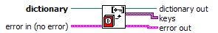

Inputs
dictionary: Reference of the source dictionary

Outputs
dictionary out: It is a reference to the source dictionary
keys: This is an array of keys present in the dictionary

Pop Item
Function Name: Dictionary Pop Item.vi
Removes and returns a single Item (key - value pair) from the dictionary.
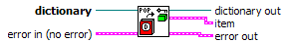

Inputs
dictionary: Reference of the source dictionary

Outputs
dictionary out: It is a reference to the source dictionary
item: This a cluster of first item (key - value pair) present in the dictionary

Get Items
Function Name: Dictionary Get Items.vi
Returns all the items (key – value pairs) within the dictionary.

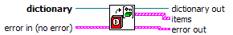

Inputs
dictionary: Reference of the source dictionary

Outputs
dictionary out: It is a reference to the source dictionary
items: This is a cluster of arrays containing all items (key - value pairs) present in the dictionary

Delete Element
Function Name: Dictionary Delete Element.vi
Deletes the element associated with key from the dictionary.

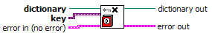

Inputs
dictionary: Reference of the source dictionary
key: This is the key of the item to be deleted from the dictionary

Outputs
dictionary out: It is a reference to the source dictionary

Clear
Function Name: Dictionary Clear.vi
Clears (Empties) the dictionary.

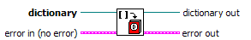

Inputs
dictionary: Reference of the source dictionary

Outputs
dictionary out: It is a reference to the source dictionary

Update
Function Name: Dictionary Update (poly).vi
Updates a key-value pair within the dictionary. If the key does not exist, then it will be added to the dictionary, and the created new? output will be TRUE
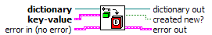

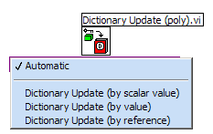

This polymorphic VI can write a single element or an entire dictionary by value or by reference.

Update (by scalar value)
Function Name: Dictionary Update (by scalar value).vi
Updates a single value in the dictionary, referenced by the key.

Inputs
dictionary: Reference of the source dictionary
key – value: key is searched in the dictionary and value is written to the associated location in the dictionary

Outputs
dictionary out: It is a reference to the source dictionary

Update (by value)
Function Name: Dictionary Update (by value).vi
Looks for all the keys and writes the respective values to the dictionary linked to specified dictionary reference.

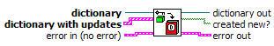

Inputs
dictionary: Reference of the source dictionary
dictionary with updates: Cluster of items to be written to the dictionary

Outputs
dictionary out: It is a reference to the source dictionary

Update (by reference)
Function Name: Dictionary Update (by reference).vi
Looks for all the keys and writes all the respective values from dictionary refnum into the dictionary linked to specified dictionary reference.

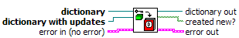

Inputs
dictionary: Reference of the source dictionary
dictionary with updates: Reference of the dictionary from which the values are to be read and written to source dictionary

Outputs
dictionary out: It is a reference to the source dictionary

References
[Ref. 1] http://www.developer.com/lang/other/article.php/630721

